**Project 2**

Dan Beck

December 15, 2020

CMSC-330 7380

Prof. Francoise Keefe

Project 2

# Lessons Learned

There was a lot to take away from this project but there were two main lessons that I learned. The first main lesson that I learned from this project was how to navigate and write code in C++. Before this course, I only ever worked with Python, Java, and HTML. While the basics of the language are similar to the ones that I am familiar with, there was a lot of syntax that I did not completely understand. Since this project was like other projects that I have done in the past, I was able to learn C++ a little bit easier than if I was building code from an unfamiliar project.

The other main lesson that I learned was how to compile multiple files together to run one program. Since everything I have done so far has been a single file, there was a lot of troubleshooting that needed to be done to figure out why the files were compiling with so many errors. After figuring out the proper way to compile multiple files, the program was much easier to grasp. It also taught me how to better navigate IDEs.

# Test Plan

* Figure 1 shows the successful compiling of all files
* Figure 2 shows the text file that will test all types of functionality
* Figure 3 shows a text file testing all types of functionality
  1. 1st example of and functionality
  2. 2nd example of and functionality
  3. Example of divide functionality
  4. 1st example of equality functionality
  5. 2nd example of equality functionality
  6. 1st example of greater than functionality
  7. 2nd example of greater than functionality
  8. 1st example of less than functionality
  9. 2nd example of less than functionality
  10. Example of minus functionality
  11. 1st example of negation functionality
  12. 2nd example of negation functionality
  13. 1st example of or functionality
  14. 2nd example of or functionality
  15. Example of plus functionality
  16. 1st example of ternary functionality
  17. 2nd example of ternary functionality
  18. Example of times functionality

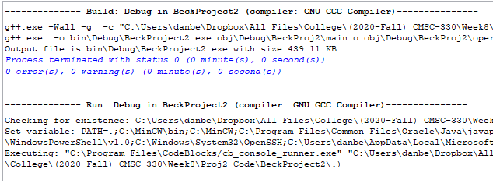

*Figure 1, Successful compiling of program with given example file*

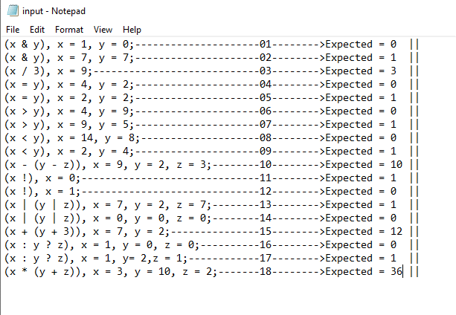

*Figure 2, Text file to be used in program*

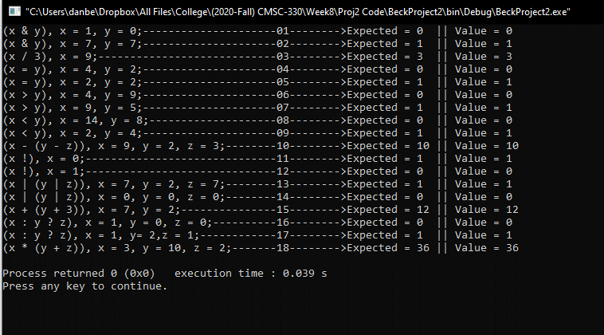

*Figure 3, Executed program with text file*